COPY WITH PREFIX:
Step 1: Create storage, two containers.
Step 2: Upload 4 files in container 1 (3 starting with same prefix (filename) and 1 with different file name.
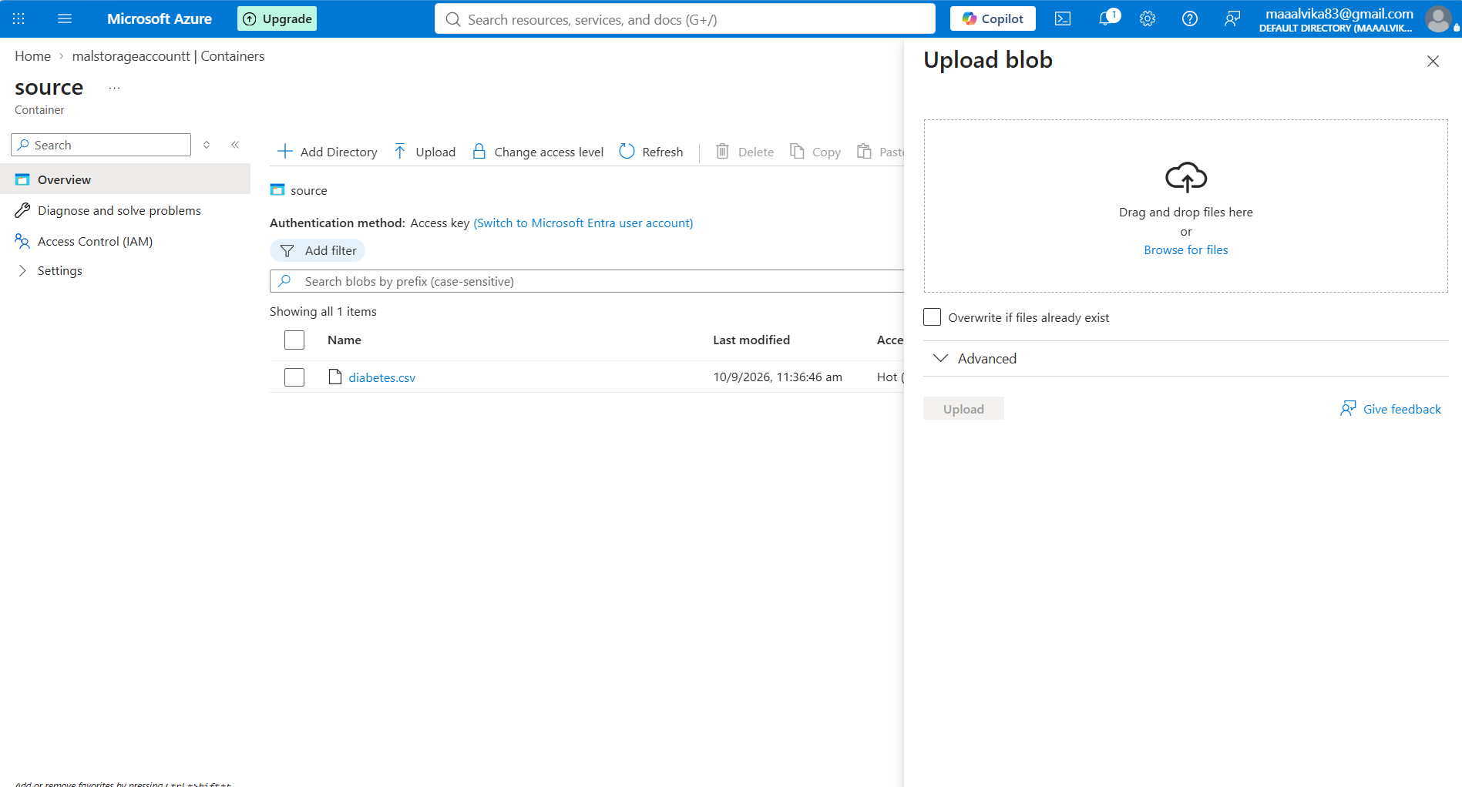

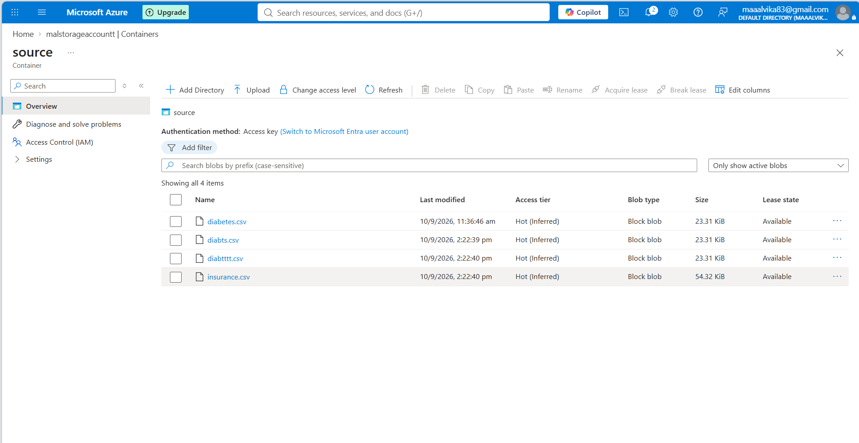

Step 3: select the source dataset, set PREFIX
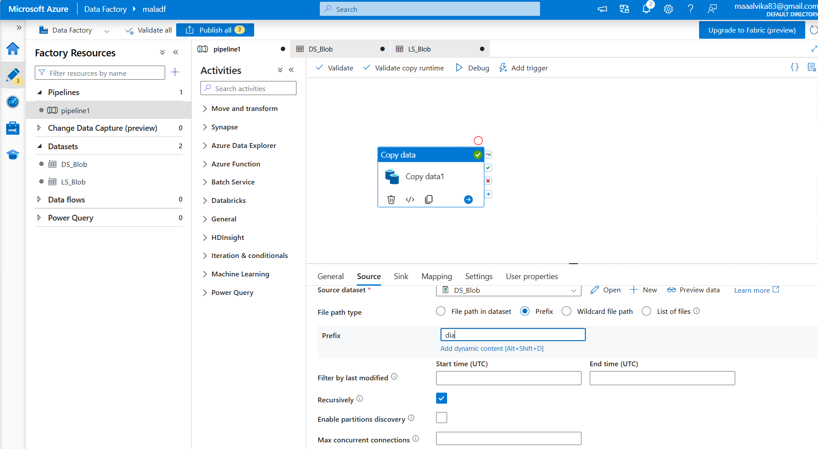

Step 4: give file path for source dataset
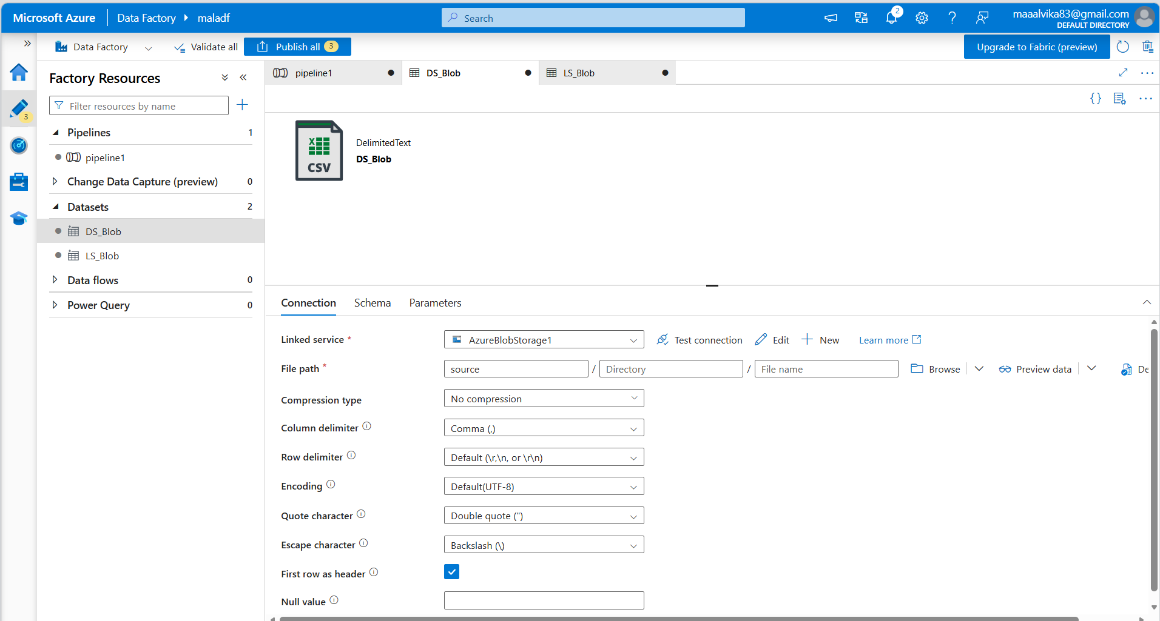

Step 4:give destination dataset and its path
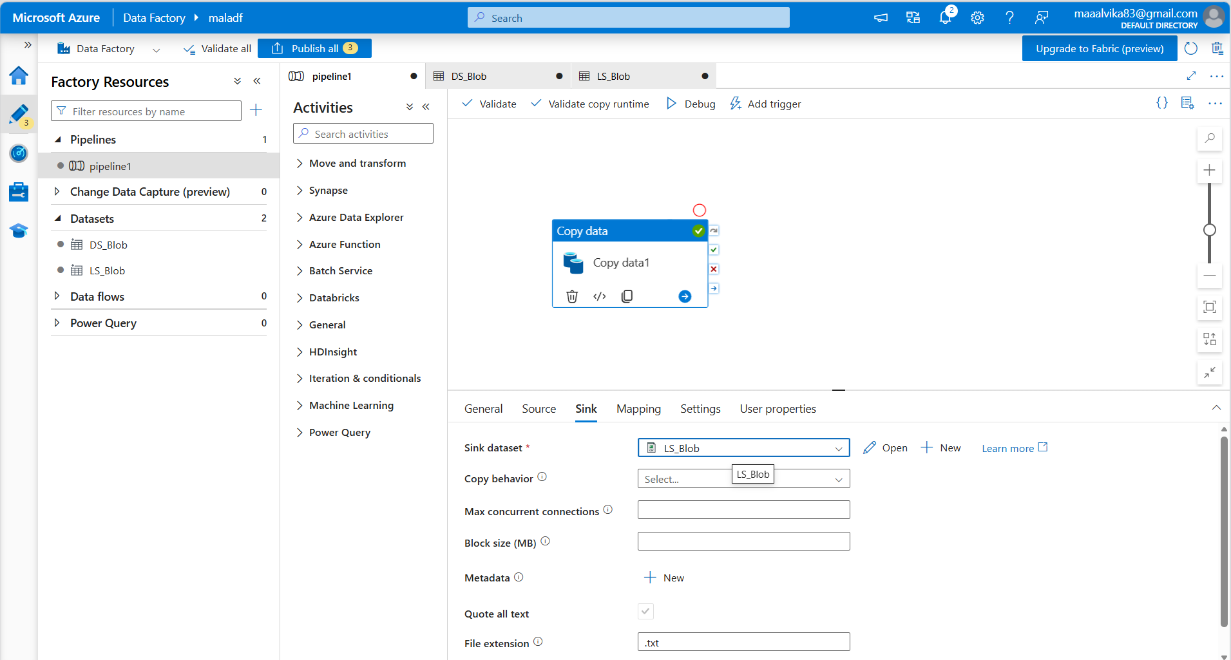
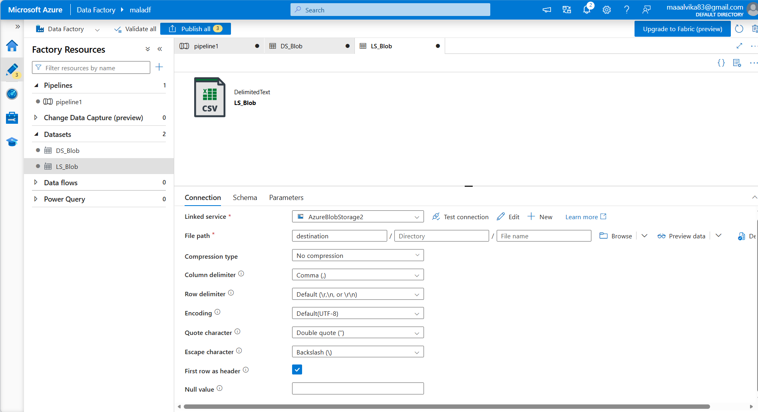

All files with given prefix are now moved from source to destination

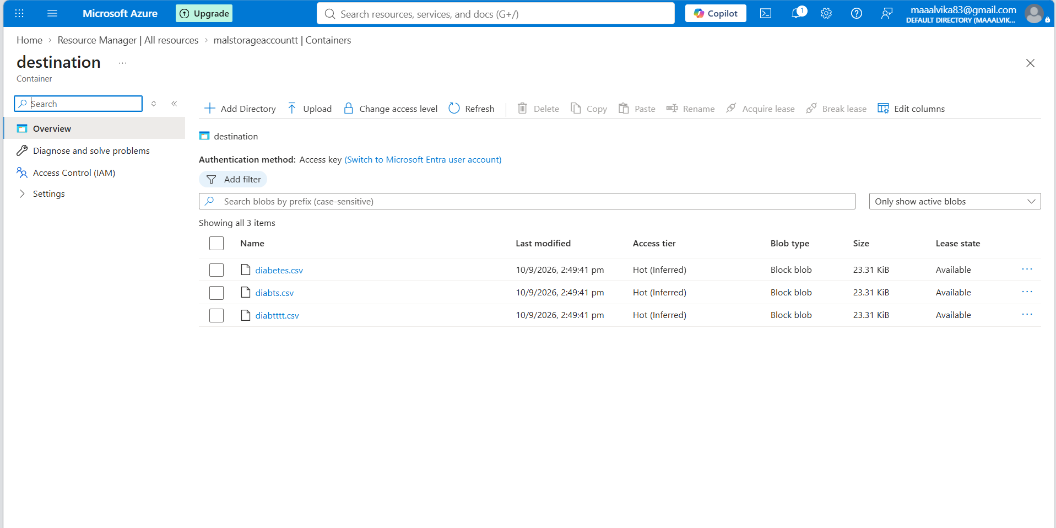

COPY WITH WILDCARD:
